A Project Report On

**EPIC RPG V2**

Submitted in partial fulfillment of the requirement for the award of the degree

MASTER OF COMPUTER APPLICATIONS

(M.C.A.)

Academic Year 2025 – 26

**Adil Belim (92400584032)**

**Krupali Shah (92400584055)**

**Niyati Bhanani (92400584019)**

|  |
| --- |
| **Internal Guide** |

Prof .Dr. Ashwin Dobariya



Rajkot-Morbi Road, At & PO : Gauridad, Rajkot 360 003. Gujarat. India.



**Faculty of Computer Applications (FCA)**



**This is to certify that the project work entitled**

**EPIC RPG V2**

**submitted in partial fulfillment of the requirement for**

**the award of the degree of**

**MASTER OF COMPUTER APPLICATIONS**

**(M.C.A.)**

**of the**

**Marwadi University**

**is a result of the bonafide work carried out by**

**Adil Belim (92400584032)**

**Krupali Shah (92400584055)**

**Niyati Bhanani (92400584019)**

**during the academic year 2025-26**

|  |  |  |  |  |
| --- | --- | --- | --- | --- |
| **Faculty Guide** |  | **HOD** |  | **Dean** |

**DECLARATION**

We hereby declare that this project work entitled **EPIC RPG V2**  is a record done by us.

We also declare that the matter embodied in this project is genuine work done by us and has not been submitted whether to this University or to any other University / Institute for the fulfillment of any course of study.

Place:

Date:

**Adil Belim (92400584032) Signature:**

**Krupali Shah (92400584055) Signature:**

**Niyati Bhanani (92400584019) Signature:**

**ACKNOWLEDGEMENT**

It is indeed a great pleasure to express my/our thanks and gratitude to all those who helped me/us. No serious and lasting achievement one can ever achieve without the help of friendly guidance and co-operation of so many people involved in the work.

We are very thankful to our faculty guide **Dr. Ashwin Dobariya,** the person who makes us follow the right steps during project work. we express my/our deep sense of gratitude to his/her guidance, suggestions and expertise at every stage. Apart from that his/her valuable and expertise suggestion during documentation of my/our report indeed helped me/us a lot.

Thanks to our friends who have been a source of inspiration and motivation that helped me/us during our project work. we are heartily thankful to our external guide **Dr. Ashwin Dobariya** for providing us an opportunity to work over this report and for their endless and great support. We are also thankful to our Head **Dr.Sunil Bajeja** and Dean **Dr. R. Sridaran** for their support as and when required. we would like to extend our gratitude towards all who directly or indirectly supported and helped us to accomplish our project work.

**Adil Belim (92400584032) Signature :**

**Krupali Shah (92400584055) Signature :**

**Niyati Bhanani (92400584019) Signature :**

**COMPANY PROFILE**

**GALMINE AI**

Galamine AI is a technology-driven company specializing in Artificial Intelligence solutions that help organizations automate processes, improve customer engagement, and enhance operational efficiency. The company develops AI-powered chatbots, virtual assistants, and customized digital solutions to support business growth and innovation.

Galamine AI operates under Amri Foundation, an organization committed to innovation, social impact, and sustainable development through technology and education.

**CONTENTS**

|  |  |  |
| --- | --- | --- |
| **Chapters** | **Particulars** | **Page No.** |
| **1** | **SYNOPSIS** |  |
| **2**  2.1  2.2  2.3  2.4 | **PREAMBLE**  General Introduction  Statement of Problem  Objective and Scope of the Study  Module Description with functionality |  |
| **3**  3.1  3.2  3.3  3.4  3.5  3.6 | **Diagrams**  Flow chart Data Flow Diagram  Use case Diagram  Sequential Diagram Class Diagram Activity Diagram |  |
| **4**  4.1  4.2  4.3 | **Review of Literature**  Origins of Text-Based RPGs  Basic Game Loop  Principles of Game Design |  |
| **5**  5.1  5.2 | **Technical Description**  Hardware Requirements  Software Requirements |  |

* + - 1. **SYNOPSIS:**

The Text-Based Python RPG Game is an interactive command-line role-playing game developed using Python. The game allows users to register, log in, create characters, explore different areas, battle creatures, earn rewards, collect items, and level up. It is designed using a modular approach with separate components for user management, gameplay mechanics, inventory, store, and utilities.

The game uses JSON-based file storage to save and load player data such as username, password, stats, coins, XP, and inventory. The goal of the project is to provide a simple yet engaging RPG experience while demonstrating Python programming concepts such as functions, loops, file handling, conditional logic, and modular coding.

This project focuses on text-based interaction instead of graphics, making it easy to run on any system with Python installed. It serves as both entertainment and a practical application of core programming skills.

**2. PREAMBLE**

**2.1 General Introduction:**

Text-based RPGs (Role-Playing Games) are one of the earliest forms of computer games, built entirely through text prompts and user choices. These games are simple yet highly interactive, relying on decision-making rather than graphics.

**2.2 Statement of Problem: (N/A)**

**2.3 Objective and Scope of the study:**

* Implement user registration and login functionality.
* Created a system for character level progression and attribute management (health, XP, coins).
* Design and developed various game modules, including hunting, adventure, inventory
* management, a store, and character profiles.
* Incorporate file-based storage for user data persistence.
* Provide a user-friendly text-based interface with clear instructions and feedback.
* **Scope:**
* The project will include core RPG elements such as character development, combat, and
* inventory.
* The game will be text-based, focusing on gameplay mechanics rather than graphical
* presentation.
* User data will be stored in a JSON file.
* The game will be developed using Python 3.x.

**2.4 Module Description with functionality:**

**2.4.1 User Management Module:**

* Description: This module handles user registration, login, and deletion.
* Functions:
* register(): Creates a new user account, storing the username and password.
* login(): Authenticates existing users and retrieves their data.
* delete_user(): Removes a user account from the system.
* load_user_data(): Loads user data from the JSON file.
* save_user_data(): Saves user data to the JSON file.

**2.4.2 Game Mechanics Module:**

* Description: This module contains the core gameplay functions, including hunting,
* adventure, chopping, and reward systems.
* Functions:
* rpg_hunt(): Simulates a hunting expedition where the player encounters creatures, gains
* rewards, and loses health.
* rpg_adventure(): Presents a more challenging adventure scenario with a single, powerful
* creature.
* rpg_chop(): Allows the player to chop wood and gather resources.
* reward(): Provides random rewards to the player.
* get_level(): Calculates the player's level based on their XP.
* check_level_up(): Checks if the player has leveled up and updates their stats.

**2.4.3 Inventory Module:**

* Description: Manages the player's items.
* Function:
* view_inventory(): Displays the items currently in the player's inventory.

**2.4.4 Profile Module:**

* Description: Displays the player's character information.
* Function:
* view_profile(): Shows the player's username, level, stats (attack, defense, health), coins, and XP.

**2.4.5 Store Module:**

* Description: Allows the player to buy items from a store.
* Function:
* store(): Displays the store's inventory and handles purchases.

**2.4.6 Main Game Module:**

* Description: The main entry point of the game, orchestrating the game loop and user
* interaction.
* Function:
* start_game(): Manages the main game loop, user input, and calls other modules.

**2.4.7 Utils Module:**

* Description: Provides utility functions and data structures used across other modules.
* Functions/Data:
* get_level(): Calculates the player's level.
* item_emojis: A dictionary mapping item names to emojis for display.

**DIAGRAMS**

**3.1 Flowchart:** 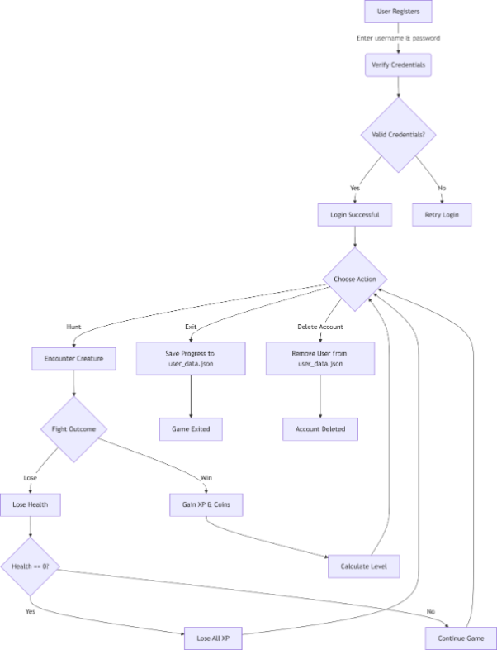

**3.2 Data flow diagram:**

**DFD-0**

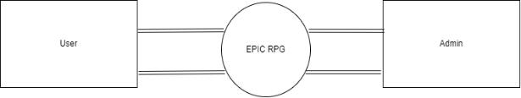

**Level-1:**

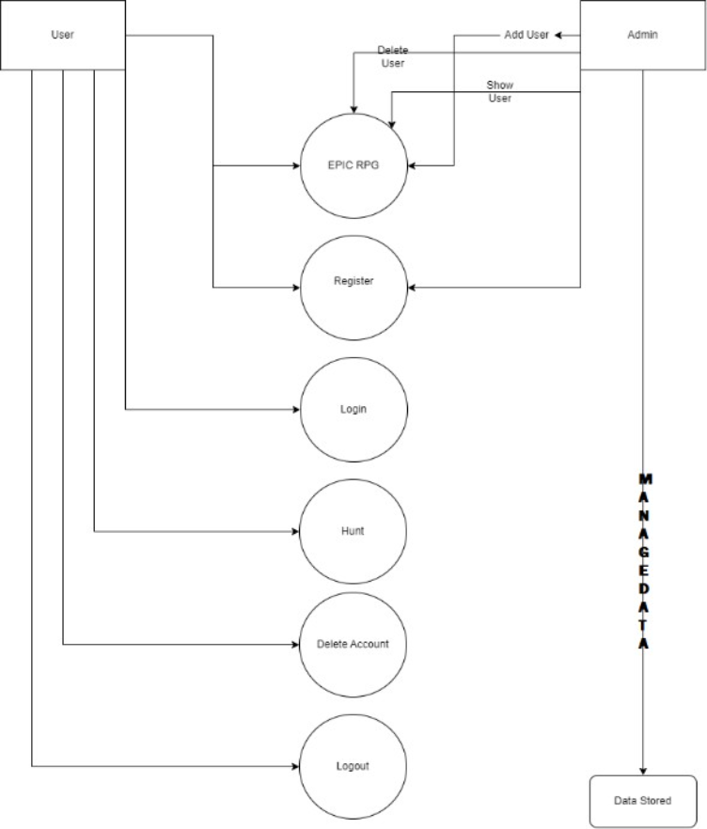

**3.3 Use case diagram:**

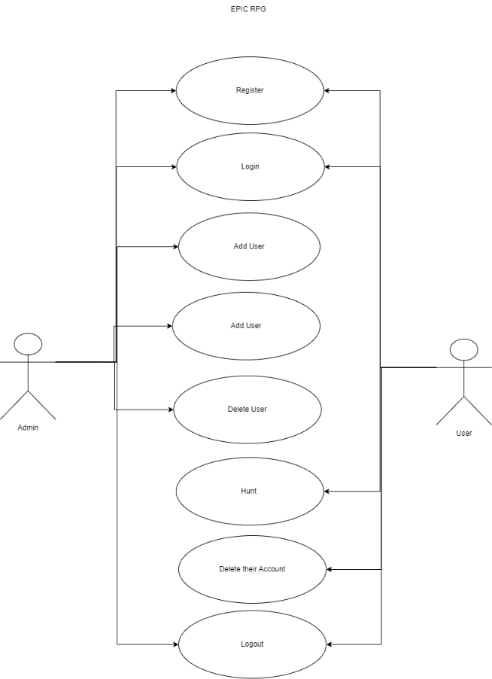

**3.4 Sequential diagram:**

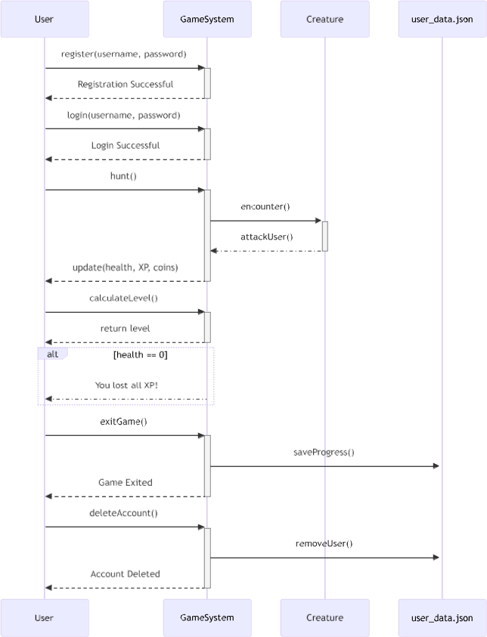

**3.5 Class diagram:**

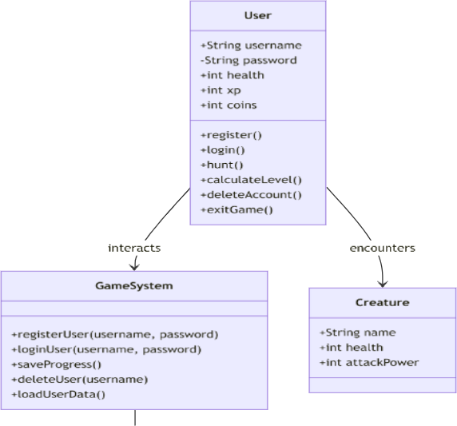

**3.6 Activity diagram:**

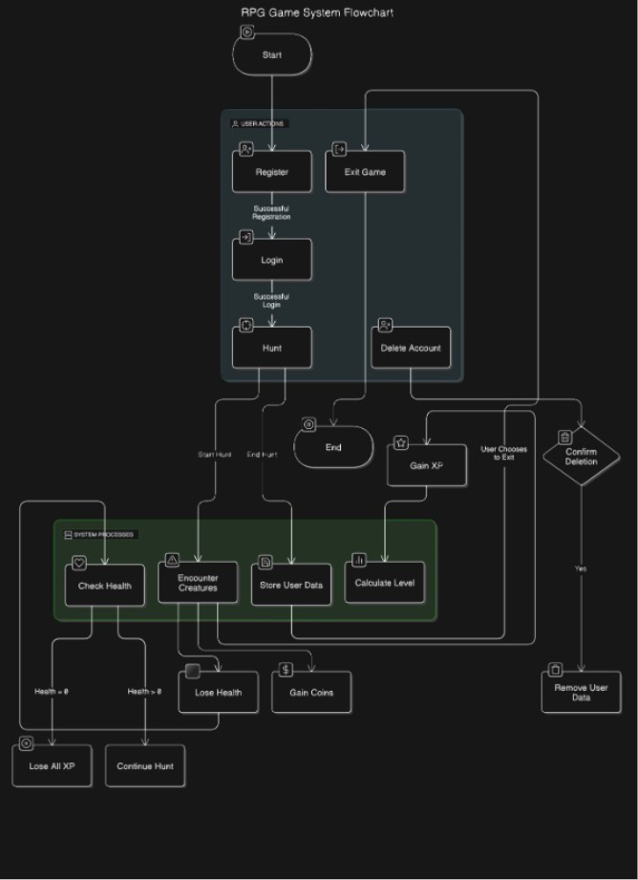

**4 Review of Literature**

**4.1 Origins of Text-Based RPGs**

* Text-based RPGs started as games with no graphics, where everything was described using text.
* Players interacted by typing commands instead of clicking or using visuals.
* Zork (1977) was one of the first popular text adventure games, developed at MIT.
* It became famous for allowing natural language commands and open exploration.
* The success of Zork led to the creation of Infocom, which released many text-based games.
* These games influenced modern RPGs by focusing on story, choices, and imagination

**4.2 Basic Game Loop**

* Every game runs on a continuous loop that keeps it active.
* The game starts and prepares data (variables, player state).
* It takes input from the player (commands or actions).
* The game processes logic (movement, combat, rewards).
* The result is shown to the player (text or visuals).
* This loop repeats until the player exits the game.

**4.3 Principles of Game Design**

* Progression: Players feel growth through leveling up or unlocking new features.
* Reward Systems: Players earn rewards like points, items, or achievements.
* Challenge Balance: The game should not be too easy or too difficult.
* Feedback: The game clearly shows the result of player actions.
* Engagement (Flow): Players stay interested when goals are clear and challenges feel fair.

**5 Technical Discription:**

**5.1 Hardware Requirements:**

Minimum:

* Any standard computer capable of running Python 3.x.
* A text terminal or console.

Recommended:

* A computer with a reasonably fast processor for smoother gameplay (though the game's demands are very low).
* A terminal with support for displaying emojis
  1. **Software Requirements:**
* Operating System: Cross-platform (Windows, macOS, Linux, etc.) as long as Python 3.x is supported.
* Programming Language: Python 3.x
* Libraries: No external libraries are strictly required beyond the Python standard library (random, time, json).